**CURRICULAM VITAE**

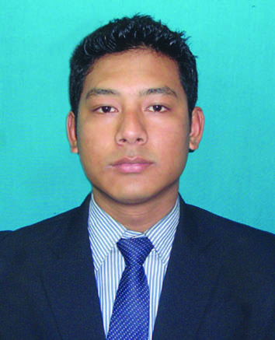

**NAME** – Dibyajyoti Moran

**Address** –

C/O – Jagannath Moran

Vill- Athengia

P.O –Rupai Siding, Pin- 786153

Dist – Tinsukia

Mobile no. – 09707392855

E-mail – dibya.daw@gmail.com

**Summer Internship :–**

* 45days summer training at Indian **Oil Corporation Limited,** Betkuchi Terminal, Ghy,Assam
* **Project Topic** – A Study of Supply Chain Management at Indian Oil CorporationLimited **(**IOCL) with special reference to Betkuhi Terminal, TOP, Guwahati, (Assam)

**Professional Qualification-**

* “Master of Business Administration” (Full Time) from University of Science and Technology, Meghalaya, Session: 2012-2014
* Specialization: Marketing and Human Resource

**Strength and Skills-**

* Self determination and dedication towards my work.
* A keen follower of punctuality.
* Structured and sincere approach towards work responsibilities.

**Career Objectives-**

To pursue a career in Marketing and contribute a profitable relationship within organization and with their valued customer.

**Educational Qualification-**

|  |  |  |  |  |
| --- | --- | --- | --- | --- |
| **Exam Passed** | **Board**  **/ University** | **Year of Passing** | **Percentage of** **Marks** | **Division** |
| B.ScHM | PTU | 2011 | 68% | 1st class |
| H.S. | AHSEC | 2008 | 55% | 2nd div |
| H.S.L.C. | SEBA | 2005 | 50% | 2nd div |

**Computer Proficiency-**

* 12 months course in Diploma in Computer Application.

**Personal Details-**

* Fathers Name – Jagannath Moran
* Date of Birth – 08 March 1989
* Marital Status – Single
* Sex – Male
* Hobbies – Bike riding, Traveling, Cooking
* Language Known – English, Assamese, Hindi, Bengoli

**Declaration**-

I hereby declare that all the information given above is true to the best of my knowledge.

Place – Guwahati

Date - (Dibyajyoti Moran**)**